Bug_01:
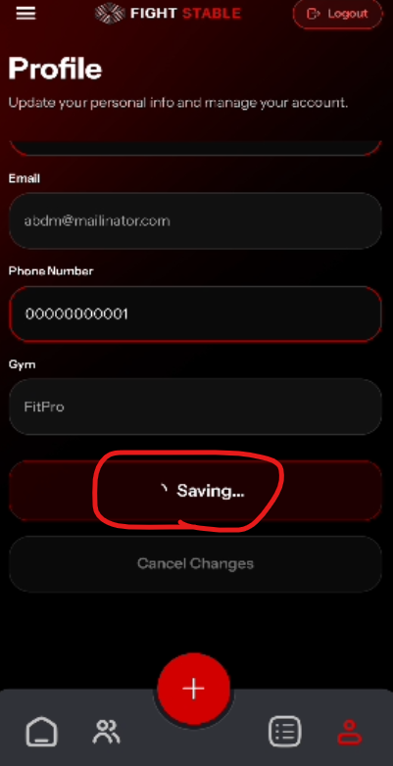
When saving the changes then entire page freeze, not scrolling
Bug_02:
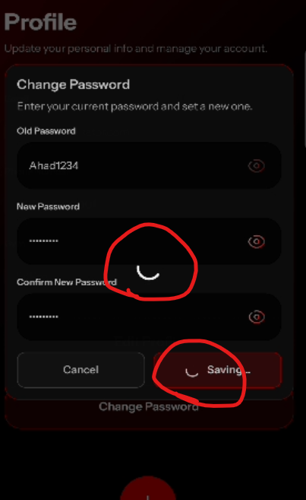
Dual loader
Bug_03:
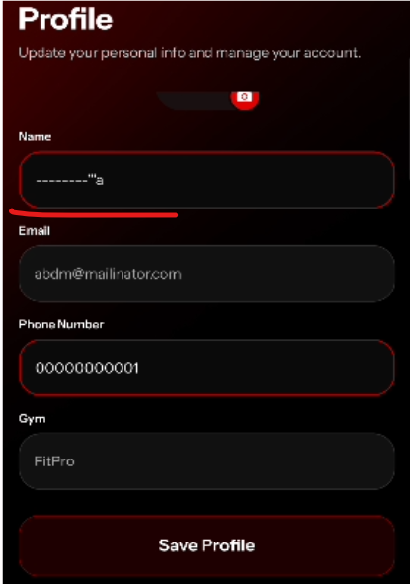
No error message
Bug_04:
Before logging out, it should ask do you want to logout ?

Bug_05:
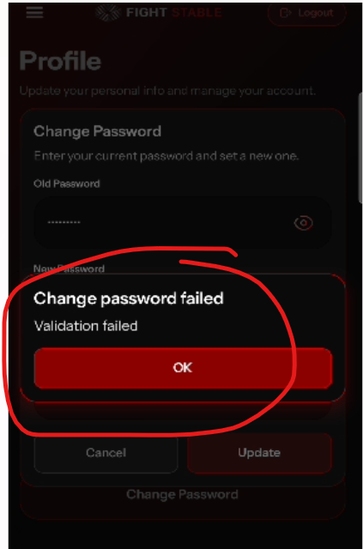
Incorrect error message when try to change password and put wrong old password

Bug_06:
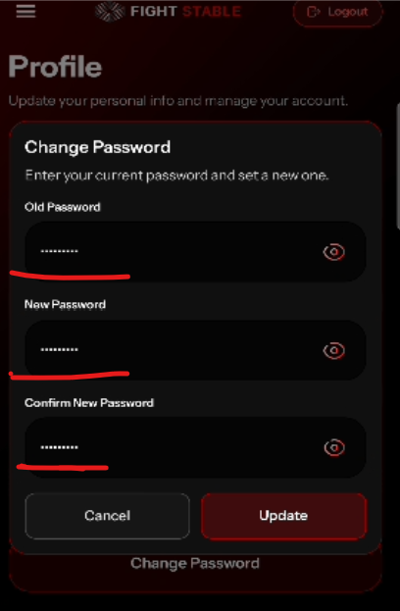
No error message appear below the fields

Bug_07:
